**Practical 2**

**Aim: Implement following data structures using Java : 1) Stack 2) Queue 3) Linked List**

1. **Stack**

**Code:**

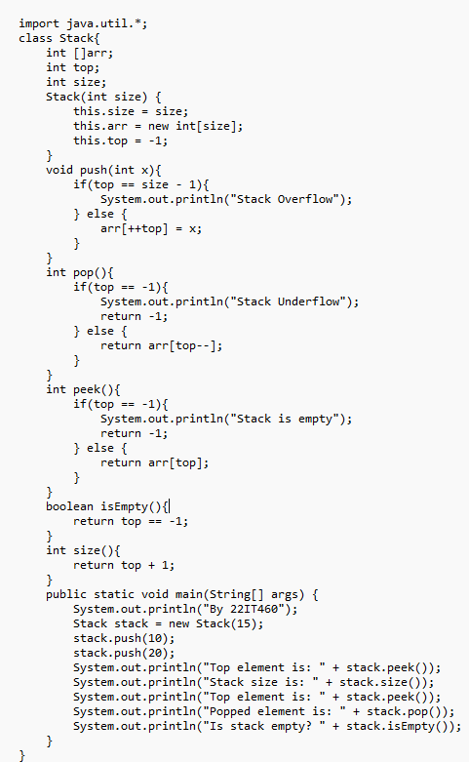

**Output:**

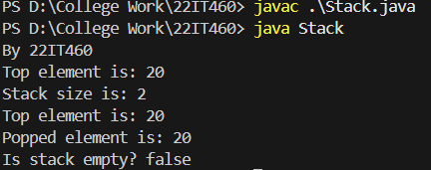

1. **Queue**

**Code:**

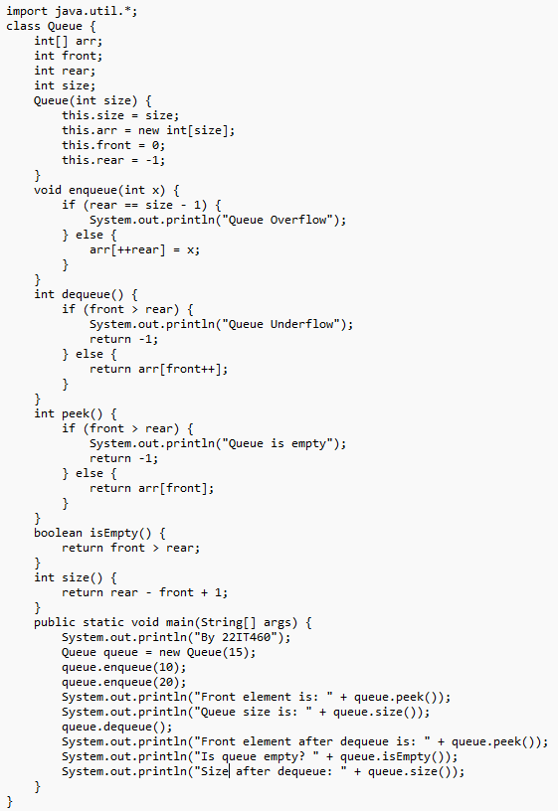

**Output:**

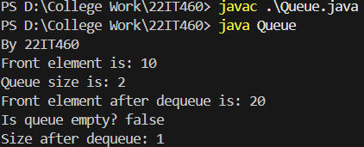

1. **Linked List**

**Code:**

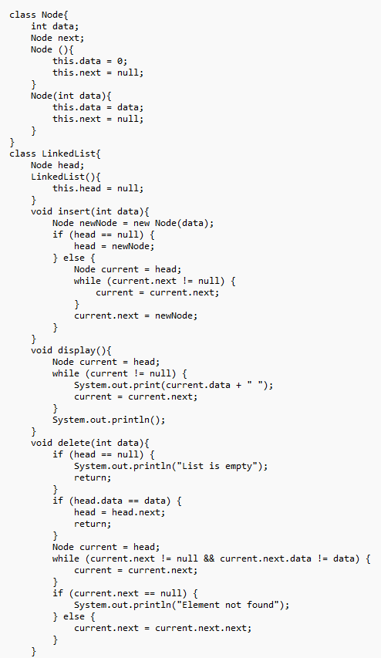

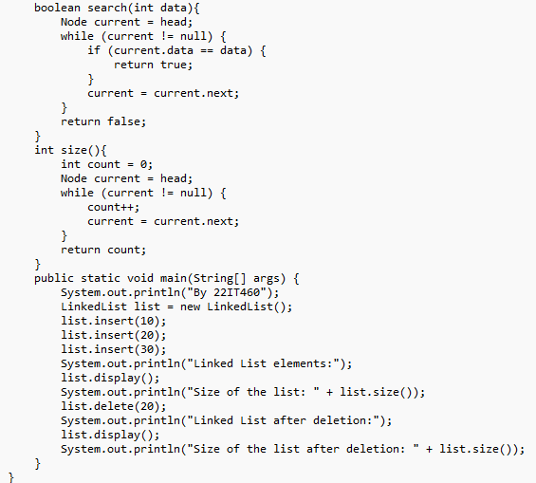

**Output:**

